Book 5

Improve Your Word Power: Test and Build Your Vocabulary

[*Caroline Taggart*](https://nlb.overdrive.com/search/creatorId?query=27905&sortBy=newlyadded)

PL-5-Improve-your-word-power

Enjoy word games and enrich your vocabulary skills with a collection of multiple-choice questions which can be played with your family. Fun facts and informative chunks of information make this an enjoyable read with unexpected surprises behind the origins of well-known words.

<http://eresources.nlb.gov.sg/ereads/proxy?id=2AA7651D-81FA-415B-B331-068F18AC3A38>

<https://nlb.overdrive.com/media/2AA7651D-81FA-415B-B331-068F18AC3A38>

<h5> Improve Your Word Power</h5>

<i>[*Caroline Taggart*](https://nlb.overdrive.com/search/creatorId?query=27905&sortBy=newlyadded)</i><br/>

<a href="https://eresources.nlb.gov.sg/ereads/proxy?id=2AA7651D-81FA-415B-B331-068F18AC3A38"><img src="/images/ PL-5-Improve-your-word-power.jpg" style="width:300px; text-align:left;"></a><br/>

London: Michael O'Mara Books Limited, 2019.<br/>

Enjoy word games and enrich your vocabulary skills with a collection of multiple-choice questions which can be played with your family. Fun facts and informative chunks of information make this an enjoyable read with unexpected surprises behind the origins of well-known words.<br/>

Borrow the eBook <a href="https://eresources.nlb.gov.sg/ereads/proxy?id=2AA7651D-81FA-415B-B331-068F18AC3A38">with the app</a> &#128241; or <a href="https://nlb.overdrive.com/media/2AA7651D-81FA-415B-B331-068F18AC3A38">online</a> &#128187;.<br/>

~~Why Won’t You Apologise?: Healing Big Betrayals and Everyday Hurts~~

*~~Harriet Lerner~~*

~~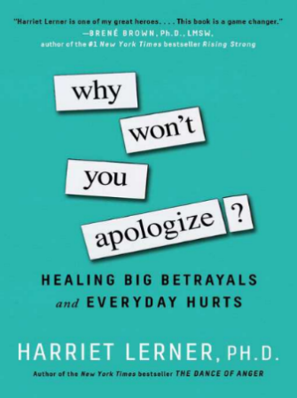~~

~~http://eresources.nlb.gov.sg/ereads/proxy?id=~~

~~New York: Touchstone, 2017~~

~~With so much time spent with each other, conflicts are bound to emerge amongst family members in these trying times. A sincere heartfelt apology can go a long way. In this “apology education”, renowned psychologist Harriet Lerner provides tips on creating meaningful apologies and offers an interesting take on how to make things right.~~

~~Borrow the eBook~~

~~http://eresources.nlb.gov.sg/ereads/proxy?id=~~

[~~https://nlb.overdrive.com/media/2621478~~](https://nlb.overdrive.com/media/2621478)